A Project Report

On

**AJ ONLINE SHOP**

Developed At

**Harivandana College**

For the fulfillment of the requirements for the

**B.C.A. – 5th Semester [2020]**

**Developed By**

**Abhi Jasani**

Submitted To



**DEPARTMENT OF COMPUTER SCIENCE**

**-: Under the Guidance of :-**

**Dr. Ashwin Rathod (Head of Department)**

**Prof. Dharmendra Ambani (Project In-charge)**

**CERTIFICATE**

This is to certify that the project report **AJ ONLINE SHOP** submitted to **Harivandana College Rajkot**, in partial fulfilment of the requirement for the Current Semester **B.C.A SEM V - 2020**, work carried out by 3 MONTHS.

The project process is carried during the present semester in computer laboratories under the supervision of a guide preferably from the college. During this semester, the student has gone through several theoretical reports such as SDLC, Database Management System, S/W Engineering etc. The matter embodied in this project is satisfactory done by the student for the fulfilment of the required semester.

**Head of Department Internal Guide**

**Dr. Ashwin Rathod Prof.Dharmendra ambani**

**ACKNOWLEDGEMENT**

* We are very thankful to the project coordinator of **Prof. Dharmendra Ambani** of Harivandana College, who has provided us a lot of support & guidance from the beginning to the end of the project development.
* A work of this nature would not have been possible without the encouragement and meticulous attention received from them. The faculties has also played a vital role in building up my project website, under their guidance andtraining it became much easier to develop aproject.
* A work of this nature would not have been possible without encouragement and meticulous.

**1.Project Profile**

**Project Title:** Aj Online Shop

**Platform:** Windows XP,7,8, 10

**Client Side:** Any Network

**Technology:** PHP

**Front End:** PHP, Html, JavaScript, CSS,boostrap

**Back End:** MYSQL

**Server:** XAMPP Server

**Documentation Tool:** Microsoft Word

**Period of Project Working:** 3 Months

**Developed by:** Abhi jasani

**Submitted to:** Saurashtra University

**2.Project Abstract**

* This website is must be use full shop electronics items likes tv, mobile, washing machine, refrigerator, oven etc.
* Many Categorties are available for electronics shopping.
* Aj Online Shop is successfully used in buy electronics items.
* You can buy with watch full specifications of products.
* you can buy online electronics items from Aj Online Shop
* Its easy to buy online with cod payment method

**3.Introduction HTML**

**What is HTML?**

HTML is a language for describing web pages.

* + HTML stands for Hyper Text Markup Language.
  + HTML is a markup language.
  + A markup language is a set of markup tags.
  + The tags describe document content.
  + HTML documents contain HTML tags and plain text.
  + HTML documents are also called web pages.

**HTML Tags**

HTML markup tags are usually called HTML tags

* + HTML tags normally come in pairs like <b> and </b>
  + The first tag in a pair is the start tag, the second tag is the end tag
  + The end tag is written like the start tag, with a forward slash before the tag name
  + Start and end tags are also called opening tags and closing tags

**HTML Elements**

"HTML tags" and "HTML elements" are often used to describe the same thing.

But strictly speaking, an HTML element is everything between the start tag and the end tag, including the tags:

**4. web Browsers**

* The purpose of a web browser (such as Google Chrome, Internet Explorer, Firefox, Safari) is to read HTML documents and display them as web pages.
* The browser does not display the HTML tags, but uses the tags to determine how the content of the HTML page is to be presented/ displayed to the user:

**5.INTRODUCTION OF CSS**

**What is CSS?**

* + CSS stands for Cascading Style Sheets
  + Styles define how to display HTML elements
  + Styles were added to HTML 4.0 to solve a problem
  + External Style Sheets can save a lot of work • External Style Sheets are stored in CSS files

**Styles Solved a Big Problem**

<h1>This is a heading</h1>

<p>This is a paragraph. </p>

<b>This is a heading</b>

When tags like <font>, and color attributes were added to the HTML 3.2 specification, it started a nightmare for web developers. Development of large web sites, where fonts and color information were added to every single page, became a long and expensive process.

To solve this problem, the World Wide Web Consortium (W3C) created CSS.

In HTML 4.0, all formatting could be removed from the HTML document, and stored in a separate CSS file.

All browsers support CSS today.

**CSS Saves a Lot of Work!**

CSS defines HOW HTML elements are to be displayed. Styles are normally saved in external.css files. External style sheets enable you to change the appearance and layout of all the pages in a Web site.

# **6.Introduction Java Script**

**What is JavaScript?**

A scripting language is a lightweight programming language.

JavaScript is programming that can be inserted into HTML pages.

JavaScript inserted into HTML pages, can be executed by all modern web browsers.

**Did You Know?**

JavaScript and Java are two completely different languages, in both concept and design. Java (invented by Sun) is a more complex programming language in the same category as C.

ECMA-262 is the official name of the JavaScript standard.

JavaScript was invented by Brendan Each. It appeared in Netscape (a no longer existing browser) in 1995, and has been adopted by ECMA (a standard association) since 1997.

JavaScripts in HTML must be inserted between <script> and </script> tags. JavaScripts can be put in the <body> and <head> section of an HTML page.

**The <script> Tag**

To insert a JavaScript into an HTML page, use the <script> tag.

The <script> and </script> tells where the JavaScript start and end.

The lines between the <script> and </script> contain the JavaScript:

# **7.Introduction PHP**

**What is PHP?**

* PHP stands for **P**HP: **H**ypertext **P**re-processor
* PHP is a widely-used, open source scripting language
* PHP scripts are executed on the server
* PHP is free to download and use

**What Can PHP Do?**

* + PHP can generate dynamic page content
  + PHP can create, open, read, write, and close files on the server
  + PHP can collect form data
  + PHP can send and receive cookies • PHP can add, delete, modify data in

Your database

* + PHP can restrict users to access some pages on your website

**Why PHP?**

* PHP runs on different platforms (Windows, Linux, Unix, Mac OS X, etc.)
* PHP is compatible with almost all servers used today (Apache, IIS, etc.)
* PHP has support for a wide range of databases
* PHP is free. Download it from the official PHP resource: [www.php.net](http://www.php.net/)
* PHP is easy to learn and runs efficiently on the server side

**What is PHP?**

* PHP stands for **P**HP: **H**ypertext **P**re-processor
* PHP is a widely-used, open source scripting language
* PHP scripts are executed on the server
* PHP is free to download and use

**What Can PHP Do?**

* + PHP can generate dynamic page content
  + PHP can create, open, read, write, and close files on the server
  + PHP can collect form data
  + PHP can send and receive cookies • PHP can add, delete, modify data inyour database
  + PHP can restrict users to access some pages on your website

**Why PHP?**

* PHP runs on different platforms (Windows, Linux, Unix, Mac OS X, etc.)
* PHP is compatible with almost all servers used today (Apache, IIS, etc.)
* PHP has support for a wide range of databases
* PHP is free. Download it from the official PHP resource: [www.php.net](http://www.php.net/)
* PHP is easy to learn and runs efficiently on the server side

# 8.Introduction MySql

**What is MySQL?**

* MySQL is a database system used on the web
* MySQL is a database system that runs on a server
* MySQL is ideal for both small and large applications
* MySQL is very fast, reliable, and easy to use
* MySQL supports standard SQL
* MySQL compiles on a number of platforms
* MySQL is free to download and use
* MySQL is developed, distributed, and supported by Oracle Corporation

The data in MySQL is stored in tables. A table is a collection of related data, and it consists of columns and rows.

**PHP + MySQL**

* PHP combined with MySQL are cross-platform (you can develop in Windows and serve on a Unix platform)

**Queries**

A query is a question or a request.

We can query a database for specific information and have a record set returned. Look at the following query (using standard SQL):

SELECT LastName FROM Employees The query above selects all the data inthe "LastName" column from the "Employees" table.

**Download MySQL Database**

If you don't have a PHP server with a MySQL Database, you can download MySQL for free her[e:http://www.mysql.com](http://www.mysql.com/)

**What is MySQL?**

•

* MySQL is a database system used on the web
* MySQL is a database system that runs on a server
* MySQL is ideal for both small and large applications
* MySQL is very fast, reliable, and easy to use
* MySQL supports standard SQL
* MySQL compiles on a number of platforms
* MySQL is free to download and use
* MySQL is developed, distributed, and supported by Oracle Corporation

The data in MySQL is stored in tables. A table is a collection of related data, and it consists of columns and rows.

**PHP + MySQL**

* PHP combined with MySQL are cross-platform (you can develop in Windows and serve on a Unix platform)

**Queries**

A query is a question or a request.

We can query a database for specific information and have a record set returned. Look at the following query (using standard SQL):

SELECT LastName FROM Employees The query above selects all the data inthe "LastName" column from the "Employees" table.

**Download MySQL Database**

If you don't have a PHP server with a MySQL Database, you can download MySQL for free her[e:http://www.mysql.com](http://www.mysql.com/)

# 9.Analysis

When I started My Project First of all I had seen shopping Sites Like [www.flipcart.com](http://www.flipcart.com/) , [www.amazon.in](http://www.amazon.in/) etc. And seen their Facility which they provide.

Then I collected the Information of products and its stocks then I collect information which i want for my Website.

I have seen many shopping websites and then I have created TV SHOP website. I have given following facilities in My website.

**9.1--Client Side**

**-Admin Side**

* View Products
* Buy Products
* View history of buy product
* Maintain both Client side and admin side
* Add Category
* Manage Category
* Add Product
* Manage Product
* View Messages

10.System Requirement

* **10.1 SOFTWARE REQUIREMENT**
* Windows XP, 7, 8, 10
* Mozilla Fire Fox latest version, Chrome latest version
* Xammp web server latest version or wampp server
* PHP 5.4.19
* MySQL 5.5.32
* Microsoft word
* Notepad++ or Microsoft visual code

###### **10.2 HARDWARE REQUIREMENT**

* Pentium –IV Processor 550 MHz or Above
* Minimum 80 GB Hard disk
* Minimum 256 MB RAM
* Mouse, Keyboard
* 4x CR-ROM drive OR USB port

11.Feasibility Study

Feasibility study is a process to check possibilities of system development. It is a method to check various different requirements and availability of financial & technical resources.

Before starting the process various parameters must be checked like estimated finance is there or not? The man power to operate the system is there or not? The man power is trained or not?

All the above conditions must be satisfied to start the project. This is why in depth analysis of feasibility is carried out.

There are three different ways feasibility can be tested:

* **Economic Feasibility**:

In this Field is no cost for me Because This the part of Study.

* **Technical Feasibility**:

AJ ONLINE SHOP Web site is basically used to see existing computer, hardware and software etc., weather it is sufficient or additional equipment’s are required? Minimum System Requirements such that it can be affordable by of the user who is having computer. All the user requires is compatible browser installed so our system is fully technical feasible

* **Operational Feasibility:**

Once the system is designed there must be trained and expert operator. From the user’s perspective our system fully operational feasible as it just requires some knowledge of computer.

12.Project Management

###### Project Planning and Scheduling

Project planning establishes a plan for the software engineering work that follows. It describes the technical tasks to be conducted, the risks that are likely, the resources that will be required, the work product to be produces, and a work schedule. Project scheduling is an activity that distributes estimated effort across the planned project duration by allocating the effort to specific software engineering tasks. It is important to note, however, that the schedule evolves overtime. During early stages of project planning, a macroscopic schedule is developed. This type of schedule identifies all software framework activities and the product functions to which they are applied. As the project gets under way, each entry on the macroscopic schedule is refined into a detailed schedule. Here, specific software tasks (required to accomplish an activity) are identified and scheduled.

###### Project Development Approach

To solve actual problems in an industry setting, software engineer or a team of engineers must incorporate a development strategy that encompasses the process, methods and tools layers and generic phase. This strategy is often referred to as process model or a software engineering paradigm. A process model for software engineering is often chosen based on the nature of the project and application, the methods and tools to be used, and the controls and deliverables that required. To solve actual problems in an industry setting, a software engineer or a team of engineers must incorporate a development strategy that encompass the process, methods, and tool layers.

###### Types of Software Process Models:

* The Linear Sequential Model (Waterfall Model)
* The Prototyping Model
* The Rapid Application Development (RAD) Model
* The Incremental Model
* The Spiral Model
* The Concurrent Development Model
* The Formal Methods Model
* The Component Based Developed Model
* Agile Software Model

Note: - Our project is based onLinear sequential Model (Waterfall Model)

* Waterfall Model

The waterfall model derivers its name due to the cascading effect from one phase to the other as is illustrated in above figure. In this model each phase well defines starting and ending point, with identifiable deliveries to the next phase. Note that this model is sometime referred to as the linear sequential model or the software life cycle model.

* Project Planning

The success of the project will depend critically upon the effort, care and skill apply in its initial planning. This looks at the creative aspects of the planning.

Before describing the role and creation of a specification, we need to introduce and explain a fairly technical term.

**13.project scheduling (pert chart and gantt chart)**

GANTT Chart

**System Design**

**Detailed Design**

**Coding**

**Unit Testing**

**Test Plan**

**Testing**

**25 - days 35 - days 15 - days15 - days**

In a PERT chart instead of making a single estimate for each task, pessimistic, likely, and optimistic estimates are also made. The boxes of PERT charts are usually annotated with the pessimistic, likely, and optimistic estimates for every task. Since all possible completion times between the minimum and maximum durations for every task have to be considered, there are many critical paths, depending on the permutations of the estimates for each task. This makes critical path analysis in PERT charts very complex. A critical path in a PERT chart is shown by using thicker arrows. The PERT chart representation of the buses scheduling problem of Figure A.

**14.System Design**

###### **14.1 Use case diagram**

* **Use case diagram for client:**



Registration

Login

Make Order

View Orders

Contact Us

Client



Database

**14.2 Use case diagram for admin:**



Registration

Add category

View category

Add product

View product

admin



Database

**15.Data Flow Diagram**

## 

* **15.1 Level 0** ➔ **Client Side**



View

Products

Visit

Make Orders

➔ **15.2 Level 1**➔ **Admin Side**



Admin

Login

View

Add, Manage

Home

Orders

Category

Messages

Product

Logout

## 

## **16.** Implementation

* 1. Admin

|  |  |  |  |  |
| --- | --- | --- | --- | --- |
| **Table Name** | | **Admin** | | |
| Description | | This table is used to strore information about admin | | |
| Key | Field Name | Type | Size | Constraints |
|  | a_unm | Varchar | 50 | Not Null |
|  | a_pwd | Varchar | 50 | Not Null |

###### 16.2 Category

|  |  |  |  |  |
| --- | --- | --- | --- | --- |
| Table Name | | **Category** | | |
| Description | | This table is used to strore information about category | | |
| Primary Keys | | c_id | | |
| Foreign Keys | | - | | |
| Key | Field Name | Type | Size | Constraints |
| * | c_id | Integer | 4 | Not Null |
|  | c_nm | Varchar | 50 | Not Null |
|  | c_image | Big Int | 100 | Not Null |
|  | c_status | Integer | 1 | Not Null |
|  | c_time | Bigint | 40 | Not Null |

16.3 product

|  |  |  |  |  |
| --- | --- | --- | --- | --- |
| Table Name | | **Product** | | |
| Description | | This table is used maintain product | | |
| Primary Keys | | p_id | | |
| Foreign Keys | | - | | |
| Key | Field Name | Type | Size | Constraints |
| * | P_id | Integer | 4 | Not Null |
|  | P_nm | Varchar | 150 | Not Null |
|  | P_cat | Integer | 4 | Not Null |
|  | P_color | Varchar | 15 | Not Null |
|  | P_size | Varchar | 50 | Not Null |
|  | P_desc | Longtext | - | Not Null |
|  | P_img | Longtext | - | Not Null |
|  | P_time | Biginteger | 40 | Not Null |
|  | P_status | Integer | 1 | Not Null |

16.4 CONTACT

|  |  |  |  |  |
| --- | --- | --- | --- | --- |
| Table Name | | **CONTACT** | | |
| Description | | This table is used to strore information about users email | | |
| Primary Keys | | c_id | | |
| Foreign Keys | | - | | |
| Key | Field Name | Type | Size | Constraints |
| * | c_id | Integer | 4 | Not Null |
|  | c_nm | Varchar | 20 | Not Null |
|  | c_mno | Integer | 10 | Not Null |
|  | c_email | Varchar | 50 | Not Null |
|  | C_time | integer | 20 | Not Null |

16.5 orders

|  |  |  |  |  |
| --- | --- | --- | --- | --- |
| Table Name | | **Orders** | | |
| Description | | This table is used to strore information about user orders | | |
| Primary Keys | | o_id | | |
| Key | Field Name | Type | Size | Constraints |
| * | o_id | Integer | 5 | Not Null |
|  | o_nm | Integer | 20 | Not Null |
|  | o_uid | Integer | 5 | Not Null |
|  | o_mno | Integer | 10 | Not Null |
|  | o_qty | Integer | 06 | Null |
|  | o_rate | Integer | 10 | Not Null |
|  | o_total | Integer | 10 | Null |
|  | o_city | Varchar | 20 | Not Null |
|  | o_add | Integer | 125 | Not Null |
|  | o_time | Integer | 20 | Not Null |
|  | o_status | integer | 1 | Not Null |

16.6 Register

|  |  |  |  |  |
| --- | --- | --- | --- | --- |
| Table Name | | **Register** | | |
| Description | | This table is used to strore information about registration | | |
| Primary Keys | | r_id | | |
| Key | Field Name | Type | Size | Constraints |
| * | r_id | Integer | 5 | Not Null |
|  | r_fnm | Varchar | 15 | Not Null |
|  | r_lnm | Varchar | 20 | Not Null |
|  | r_email | Varchar | 40 | Not Null |
|  | r_phone | Integer | 10 | Null |
|  | r_gerder | Varchar | 07 | Not Null |
|  | r_pwd | Varchar | 20 | Null |
|  | r_time | Integer | 20 | Not Null |
|  | r_status | Integer | 1 | Not Null |

* 1. logs

|  |  |  |  |  |
| --- | --- | --- | --- | --- |
| **Table Name** | | **Logs** | | |
| Description | | This table is used to strore information about login data | | |
| Key | Field Name | Type | Size | Constraints |
| * | l_id | Integer | 5 | Not Null |
|  | l_email | Varchar | 50 | Not Null |
|  | l_time | integer | 20 | Not Null |

**17.Project Management**

**Aj online shop** site had managed two sides.

* + 1. Client Side
    2. Admin side

⇨**17.1 Client side**

* + - * Visit
      * View Products
      * Buy Products
      * Make Order
      * View Orders

⇨**17.2 Admin side**

* Add Category
* Manage Category
* Add Product
* Manage Product
* View Orders
* View Messages

## Screen Shot of AJ ONLINE SHOP

* Index page

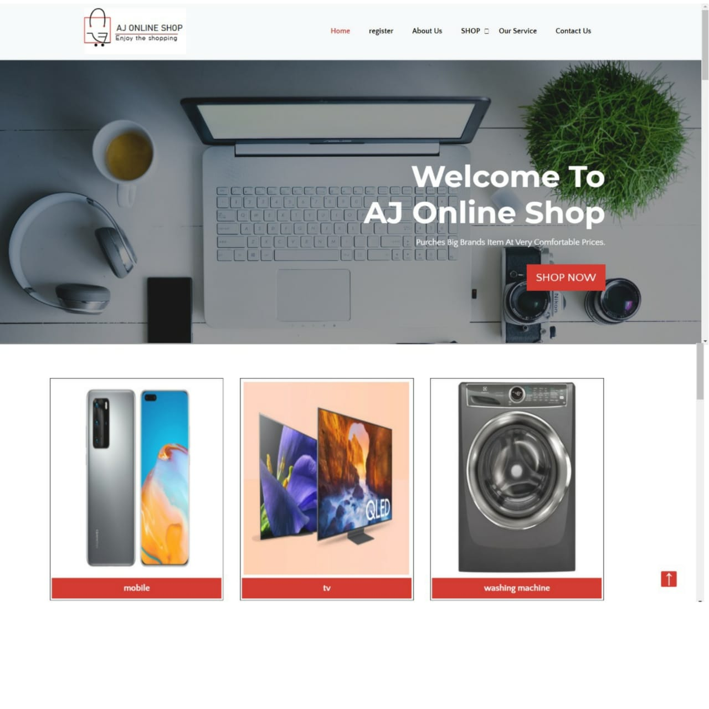

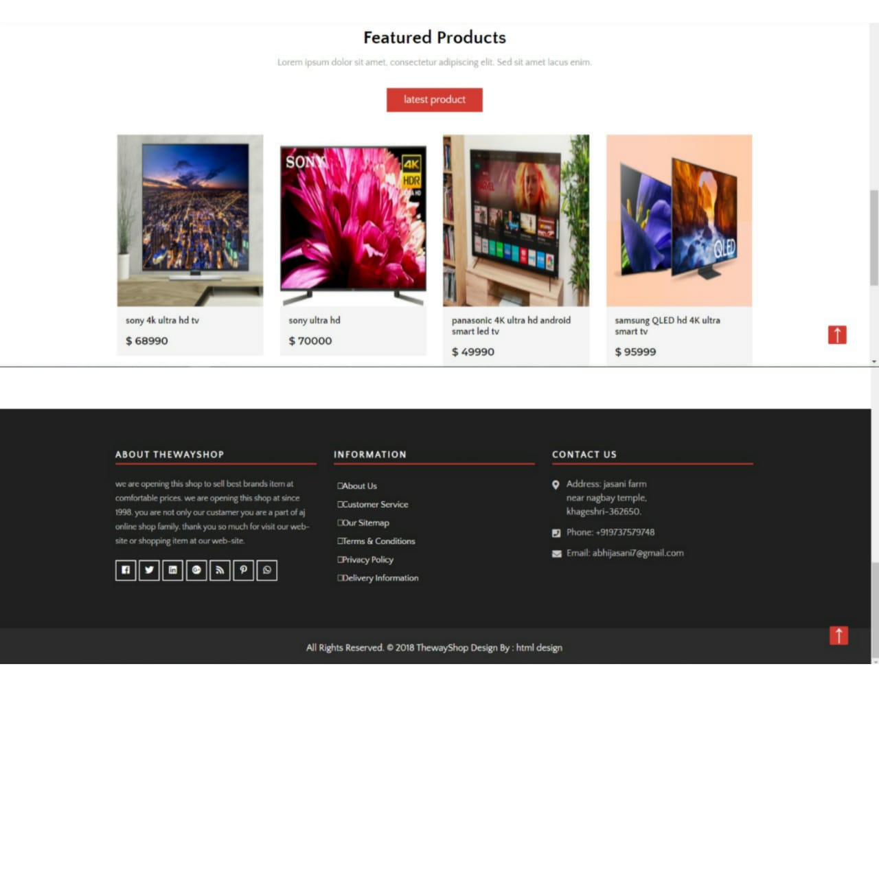

* Register page

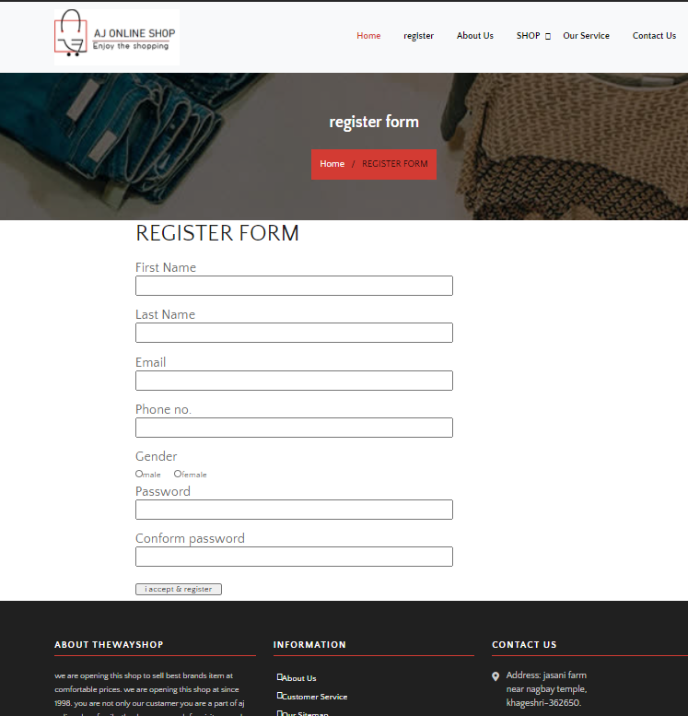

* About us page

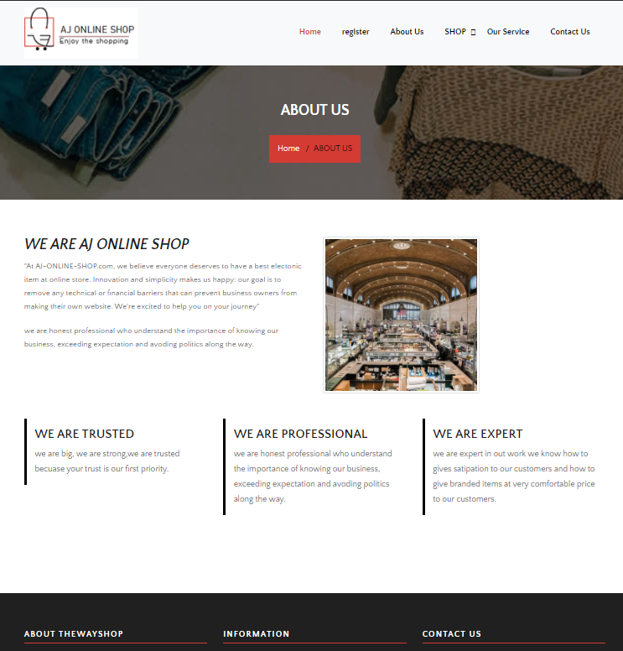

* Our service page

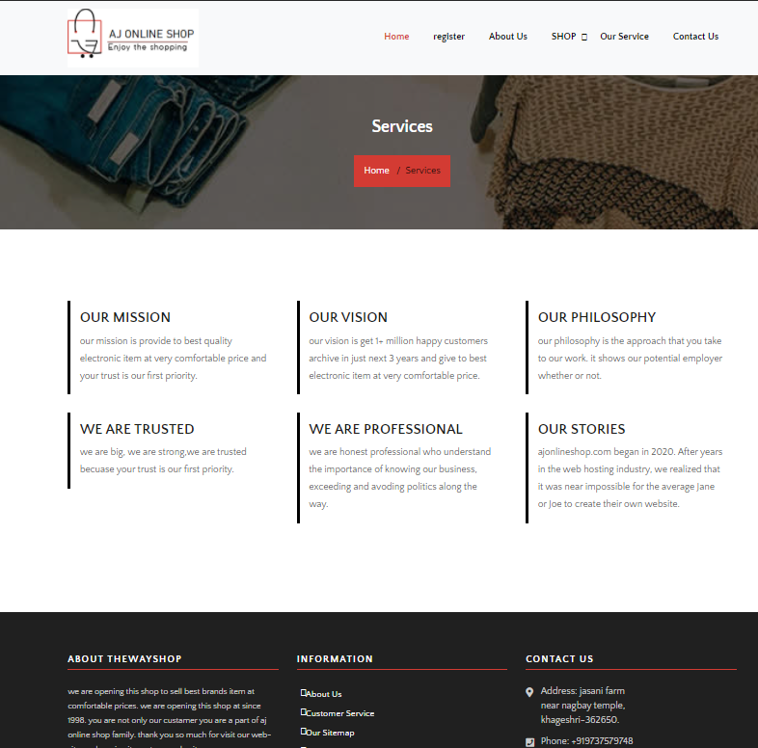

* Contact-us page

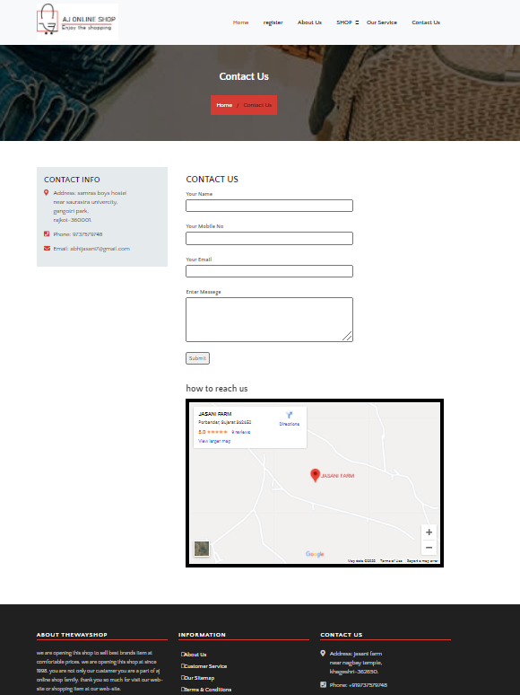

* Cart page

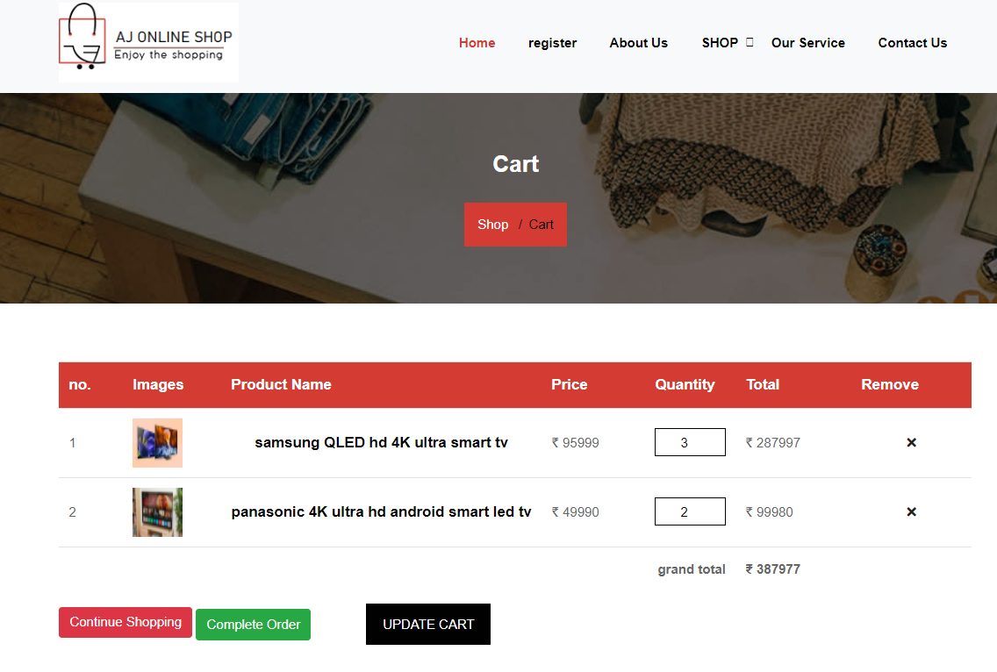

* Login page

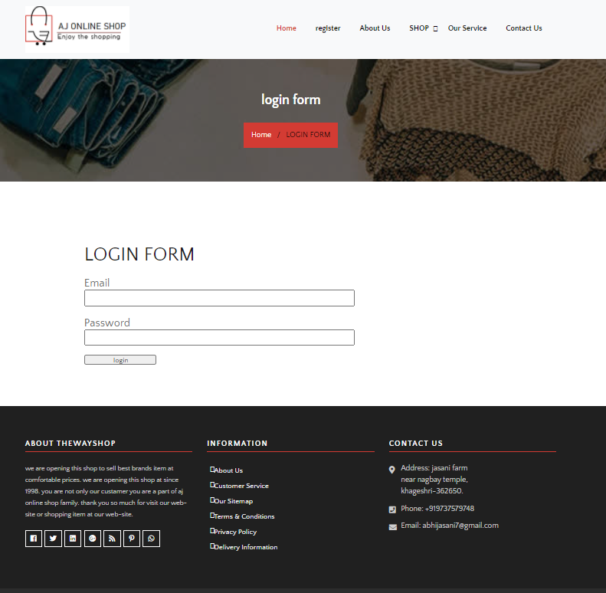

* All category list page

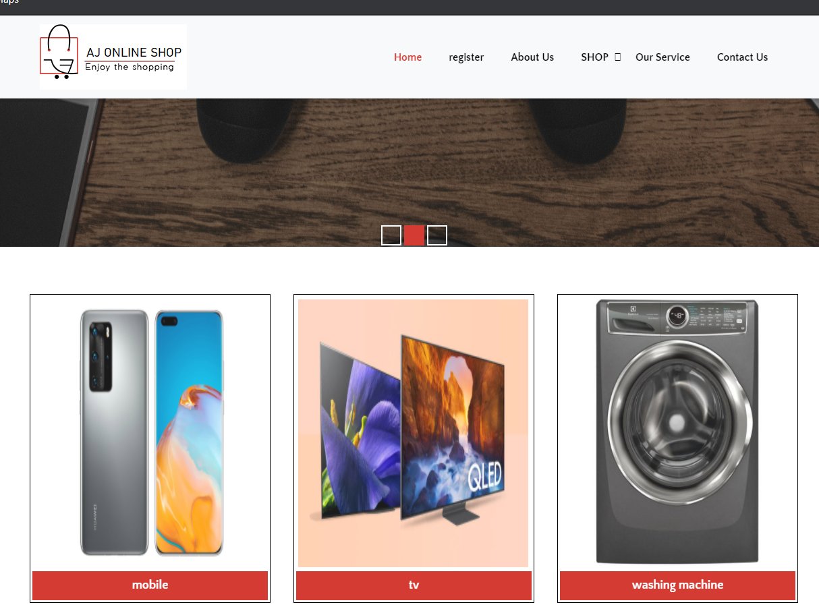

* Category item page

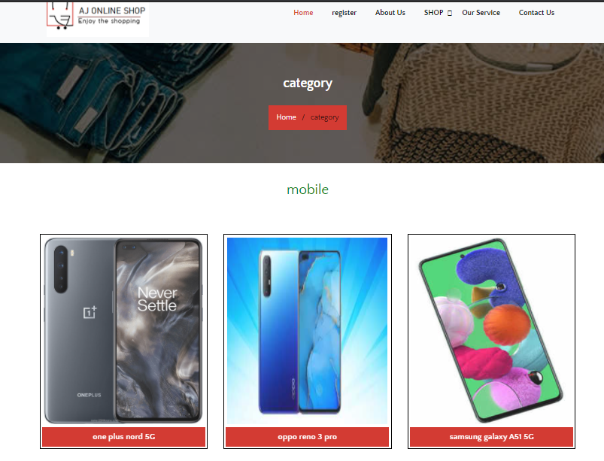

* Single category item page.

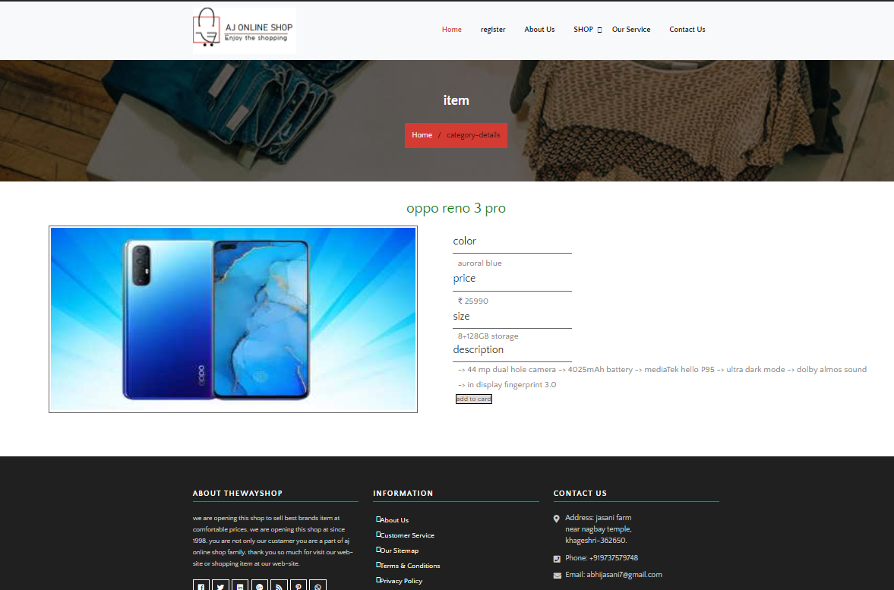

* Order page

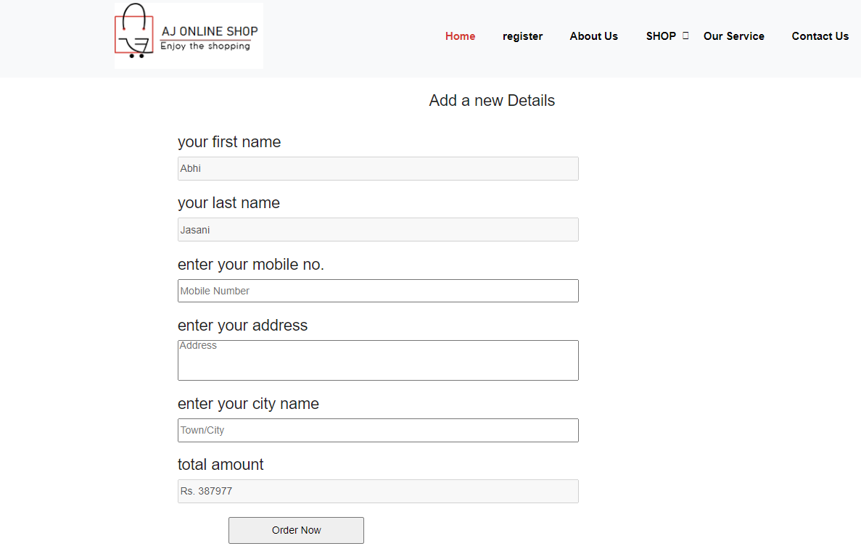

* My-account page

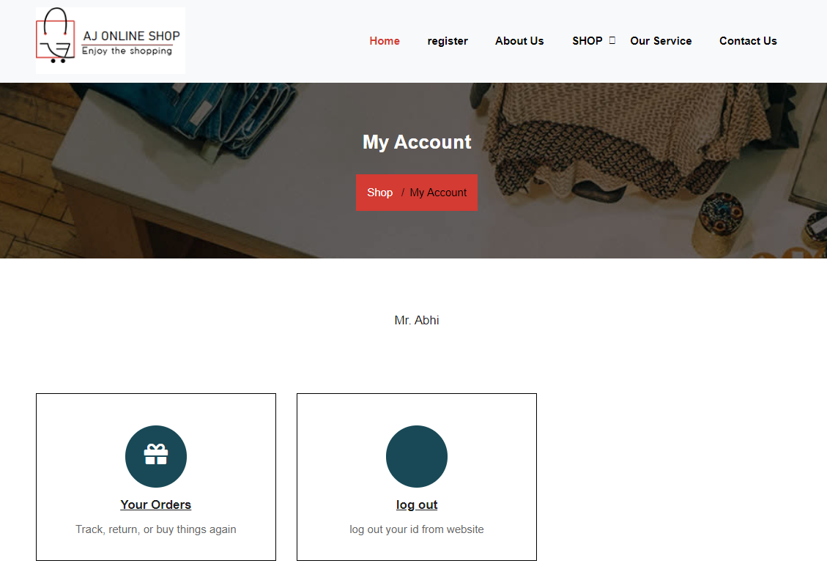

* Order history page

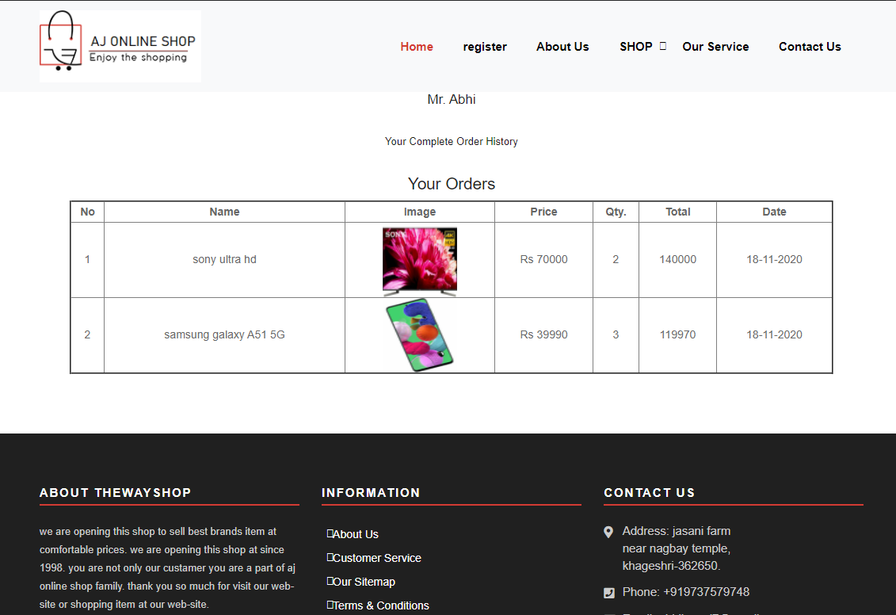

* Admin side screen shot
* Index page

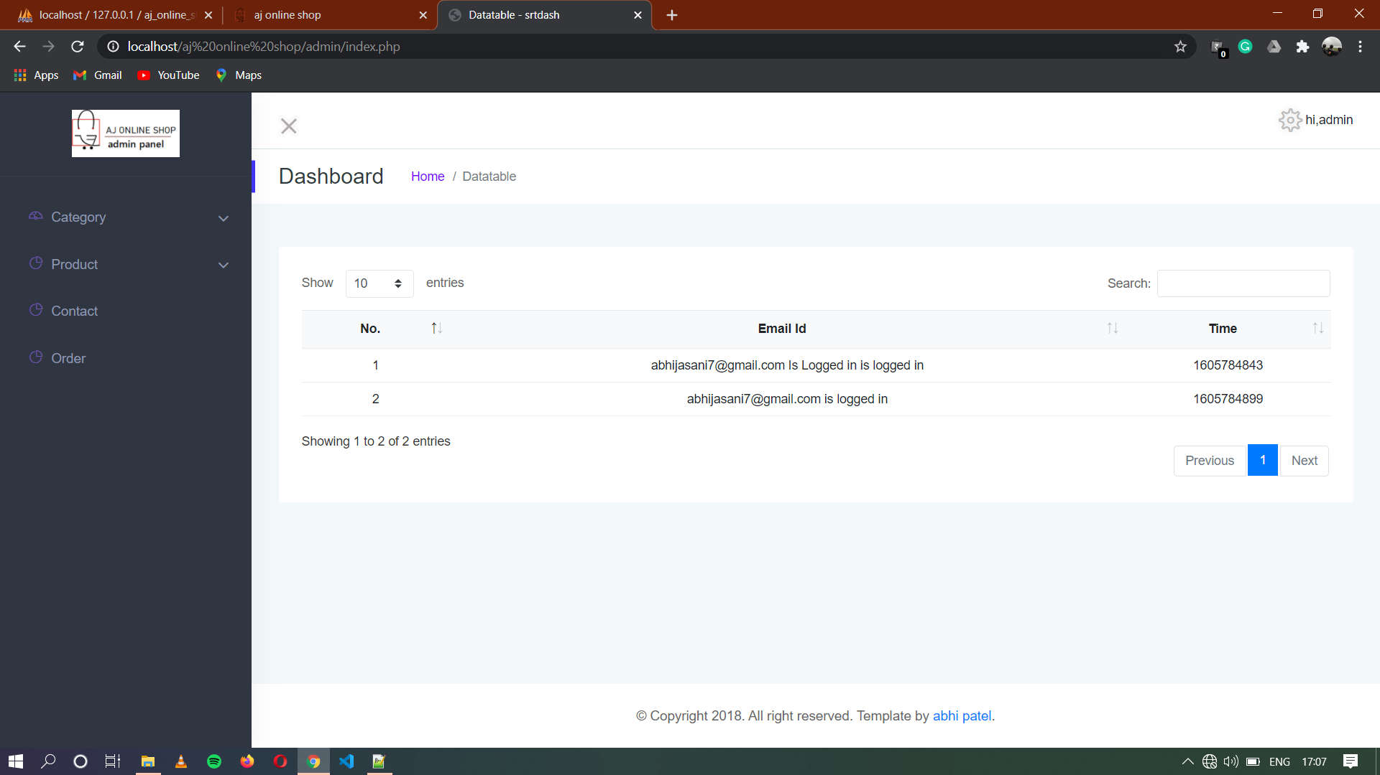

* Add category page

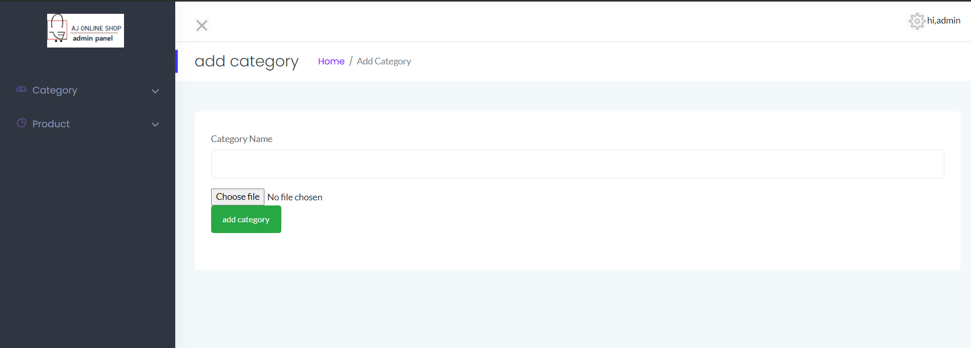

* Category view page

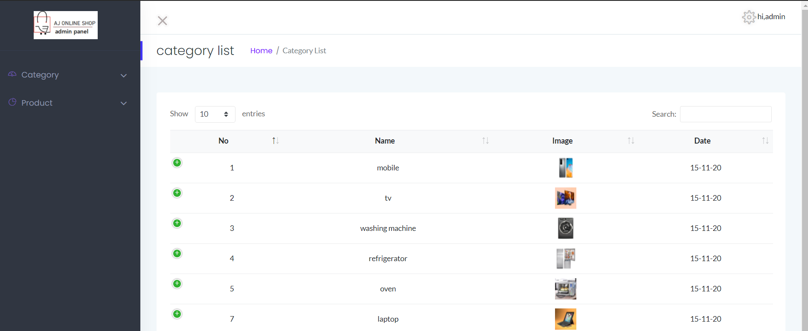

* Caregory edit page

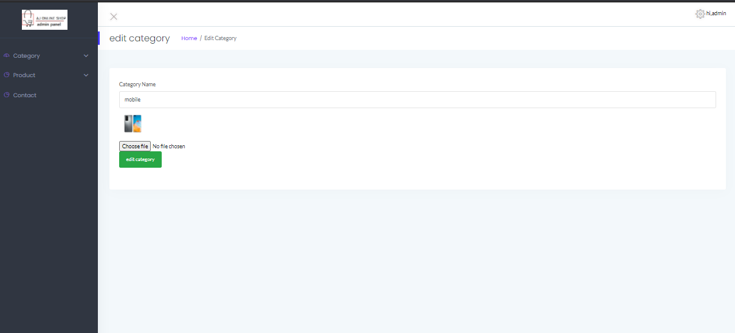

* Add Product page

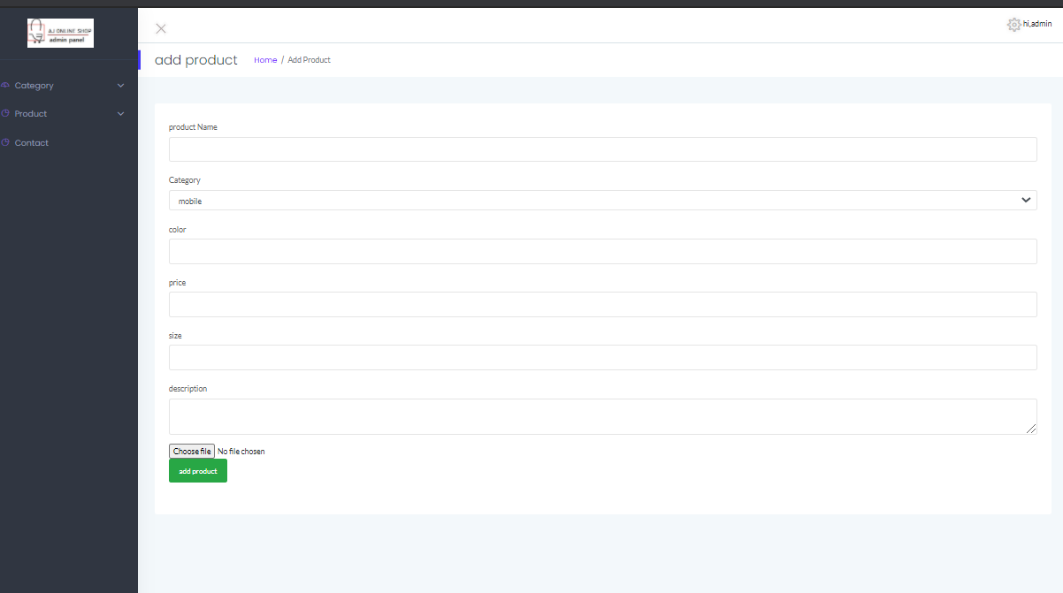

* View Category page

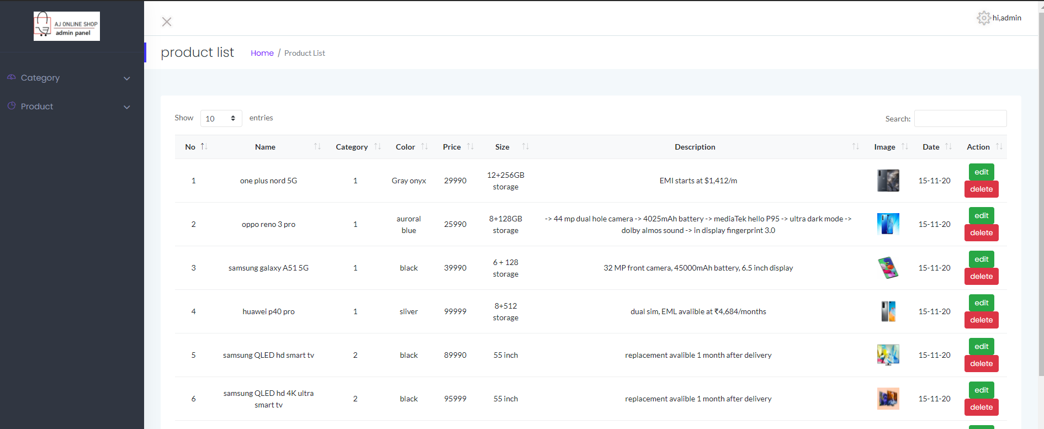

* Edit product page

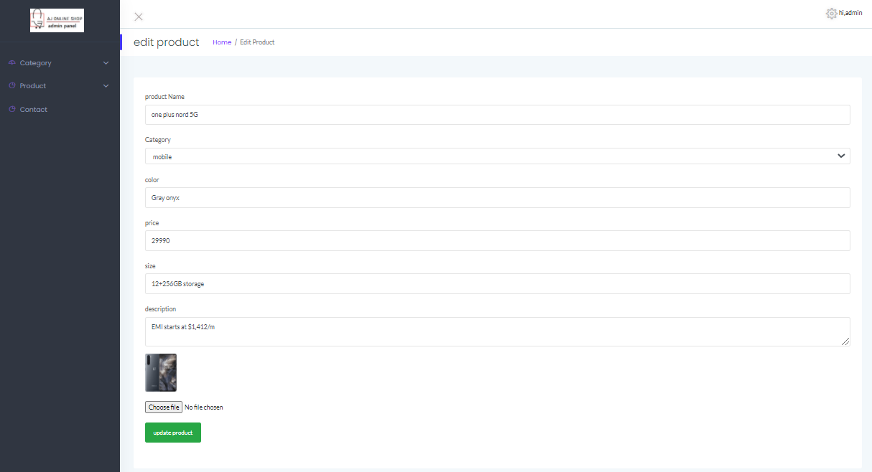

* Login page

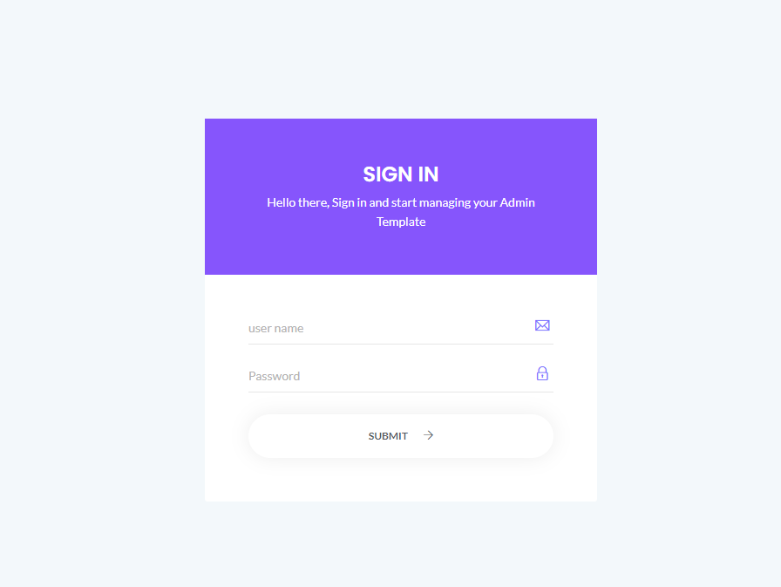

* Order view page

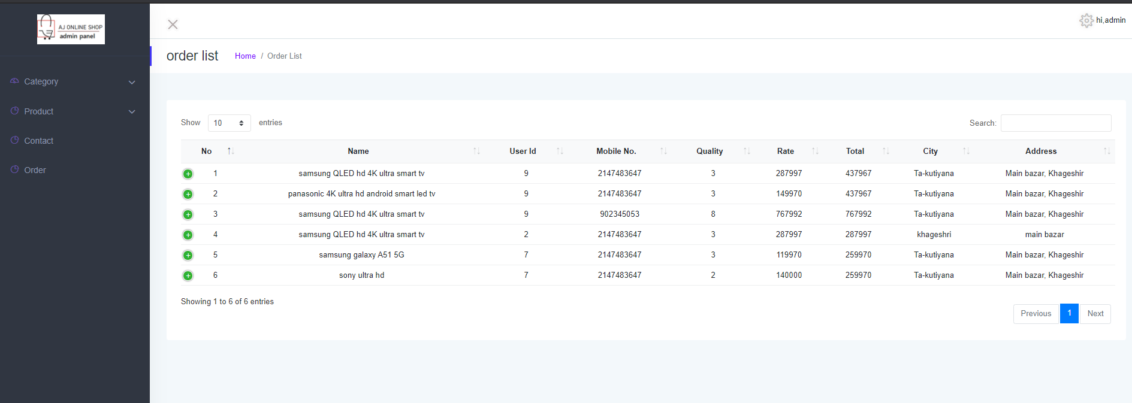

**19.Testing**

**White Box Testing**

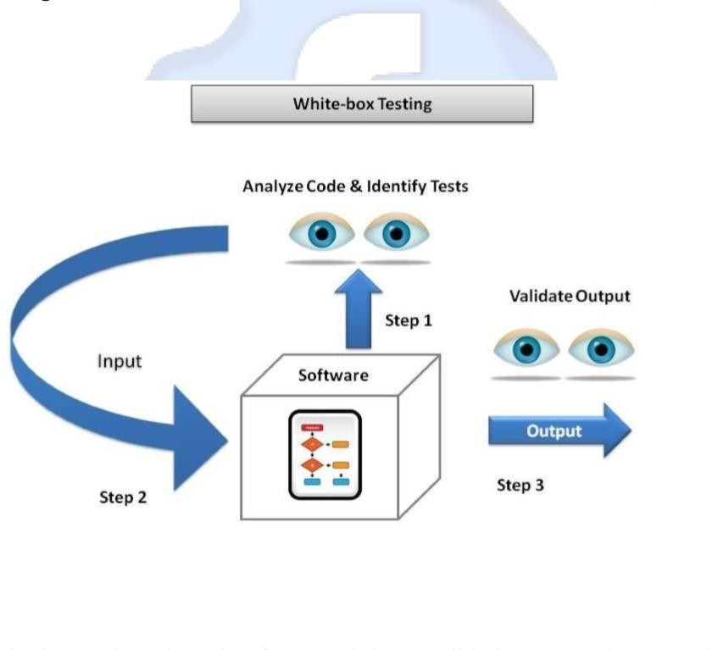White Box Testing is the testing of a software solution's internal coding and infrastructure. It focuses primarily on strengthening security, the flow of inputs and outputs through the application, and improving design and usability. White box testing is also known as clear, open, structural, and glass box testing.

I had tested Registration form and their validation. It works properly as well as all the facilities of our website like upload image, searching, Comment andlike are works properly.

I had tested admin side as well client side. I had Tested All Pages and No Query about That.

20.Limitations

**There are some limitations for the current system to which solutions can be provided as a future development**

* **Notification**

You cannot show the notification.

###### **Chatting**

In email, you cannot do chat with your Client person and other user.

###### **Our own delivery system**

Currently we don’t provide own delivery of orders.

###### **Payment system**

Online banking payment is not available

### **Bibliography**

Sites Visited:

[www.amazon.in](http://www.amazon.in) [www.flipcart.com](http://www.flipcart.com)

